2.22 Main Question (สำหรับแสดงข้อสอบ)

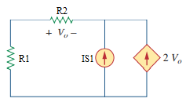

Given *Is*1 = 6 A, *R*1 = 10 Ω, *R*2 = 10 Ω.

Find

Variables (สำหรับเขียนโค้ดเพื่อหาคำตอบ)

Random variables

IS1 = {1:10};

R1 = {1:10}; R2 = {1:10};

Global variables

#IS1 = 6; R1 = 10; R2 = 10;

V = -IS1\*R2/(2\*R2+1);

Part (กรอกคำตอบ)

1. *V*o = V = -2.8571 V

3.1 Main Question (สำหรับแสดงข้อสอบ)

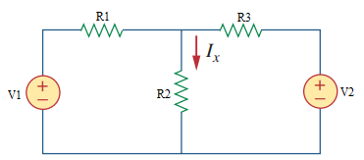

Given *E1* = 12 V, *E2* = 9 V, *R*1 = 20 Ω, *R*2 = 10 Ω, *R*3 = 40 Ω.

Find

Variables (สำหรับเขียนโค้ดเพื่อหาคำตอบ)

Random variables

E1 = {-20:20}; E2 = {-20:20};

R1 = {1:50}; R2 = {1:50}; R3 = {1:50};

Global variables

#E1 = 12; E2 = 9; R1 = 20; R2 = 10; R3 = 40;

V = (R1\*R2\*E2+R2\*R3\*E1)/(R1\*R2+R2\*R3+R1\*R3);

I = V/R2;

Part (กรอกคำตอบ)

1. *I*x = I = 0.4714 A

3.3 Main Question (สำหรับแสดงข้อสอบ)

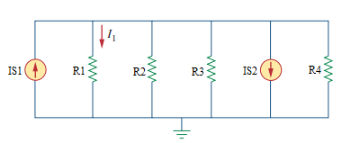

Given *Is*1 = 8 A, *Is*2 = 20 A, *R*1 = 10 Ω, *R*2 = 20 Ω, *R*3 = 30 Ω, *R*4 = 60 Ω.

Find

Variables (สำหรับเขียนโค้ดเพื่อหาคำตอบ)

Random variables

IS1 = {-20:20}; IS2 = {-20:20};

R1 = {1:100}; R2 = {1:100}; R3 = {1:100}; R4 = {1:100};

Global variables

#IS1 = 8; IS2 = 20; R1 = 10; R2 = 20; R3 = 30; R4 = 60;

V = (IS1\*R1\*R2\*R3\*R4-IS2\*R1\*R2\*R3\*R4)/(R2\*R3\*R4+R1\*R3\*R4+R1\*R2\*R4+R1\*R2\*R3);

I = V/R1;

Part (กรอกคำตอบ)

1. *I*1 = I = -6 A

3.5 Main Question (สำหรับแสดงข้อสอบ)

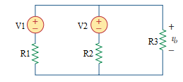

Given *E*1 = 4 V, *E*2 = 5 V, *R*1 = 10 Ω, *R*2 = 8 Ω, *R*3 = 6 Ω.

Find

Variables (สำหรับเขียนโค้ดเพื่อหาคำตอบ)

Random variables

E1 = {1:10}; E2 = {1:10};

R1 = {1:10}; R2 = {1:10}; R3 = {1:10};

Global variables

#E1 = 4; E2 = 5; R1 = 10; R2 = 8; R3 = 6;

V = (R2\*R3\*E1+R1\*R3\*E2)/(R1\*R2+R1\*R3+R2\*R3);

Part (กรอกคำตอบ)

1. *V*o = V = 2.617 V

3.7 Main Question (สำหรับแสดงข้อสอบ)

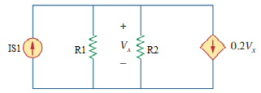

Given *Is*1 = 2 A, *R*1 = 10 Ω, *R*2 = 20 Ω

Find

Variables (สำหรับเขียนโค้ดเพื่อหาคำตอบ)

Random variables

IS1 = {1:10};

R1 = {1:10}; R2 = {1:10};

Global variables

#IS1 = 2;

#R1 = 10; R2 = 20;

V = IS1\*R1\*R2/(R1+R2+0.2\*R1\*R2);

Part (กรอกคำตอบ)

1. *V*x = V = 5.714 V